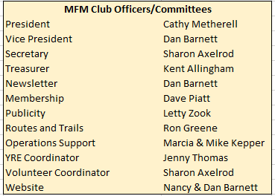

A new newsletter editor!
Please provide YOUR Inputs—Travel, Comment, Pictures, Topics to Dan at dnlcssb@aol.com

Renew your membership, see page 3.
Comments from the Vice President
by Dan Barnett
Any organization to succeed, requires volunteers. The Mid Florida Milers thank Mike and Joan Lanpher and Sharon Predham for their years of dedicated service. Mike has been our Trail Master for the past 27 years, Joan has been our club Secretary and Vice President, and Sharon has been our Treasurer for the past 10 years. Each of them have made their mark on the excellence achieved by our club and each of them will be missed for the impact they have made. Mike and Joan have moved to South Carolina where I am sure they will continue doing walks and Sharon is currently on a camping adventure and we will see at our future walks. In order to fill the void with these outstanding volkssporters stepping down, we have two outstanding volunteers stepping up. Kent Allingham will be our new Treasurer and Ron Greene will be our Routes and Trails coordinator. Our Board of Directors has reviewed the duties previously performed by Mike and Sharon and has implemented a way in which their respective responsibilities will be shared by other club members in order to lessen the load. We thank these volunteers and look forward to our club having continued success.

Let us get together this warm quarter and enjoy a walk: July 3, 17 & 31, Aug 7 & 21, Sep 4 & 18. See page 4.
Few musings from your President, by Cathy Metherell
I would first like to thank Sharon Predham and Mike Lanpher for their many years of service to the Mid-Florida Milers as Treasurer and Trail Master. Your contributions to the club and Walk Around Florida have been outstanding! Several weeks ago I did my 500th walking event, which was the downtown walk. One thing I like is how route changes over the years so you do not see the same house or building every time you do it or even different plants blooming along the way. One thing about walking is learning history of the place you are walking. Example is, I did the Miami walk in May and reading about all the Art Deco hotels along Ocean Dr. Another one is the Downtown walk. Thank you to all who do the research for the walks. The first walk I ever did, started at a Panera Bread in Lake Mary in late 2010 and the first walk I received credit for was the Maitland walk in 2011. First few years I only did Mid-Florida Milers walks. Of all the walks in Orlando area I like best is Celebration because of the shady streets and trails to walk on. Then I learned there were seven other clubs in the state of Florida that had walks. When I saw that some of theirs included beach walking, you guessed it, I headed to the beach. Yes the beach is my happy place. There are two Happy Wanderers walks that I like. They are Cocoa Beach and Flagler Beach. In the last year I have been doing both those walks and even saw a rocket launch from the Cape. Suncoast Sandpipers walks I like are Lido Key and the downtown St Pete walk. The new St. Pete pier is really nice. In 2013 I started planning vacations around where I could find AVA walks. Some of the walks I enjoyed are Cape Hatteras NC where I took the 257 steps to the top of the tallest lighthouse in North America. My knees felt it for four days. De Moines Iowa was a nice one that starts at the Botanical Garden. Another, is the quirky town of Fargo ND. The entire time I walked New Orleans, I heard some type of music along the entire route. I have done walks in 14 states so far and will be adding more this summer on my way to the AVA Convention in Madison Wisconsin. When I went to England in 2015 I did three walks there. The London walk took me along both south and north banks of the Thames River passing Big Ben, Houses of Parliament and the Globe Theater. Another one, included Kew Gardens and Richmond Park area of London. Cambridge University, I passed by 500 + year old buildings. I could feel the energy of being in a collage town. Last but not least, I would like to mention are the people I have met along the trail in different clubs. If it were not for you this would not be possible. Thank you to all who support volkssporting!
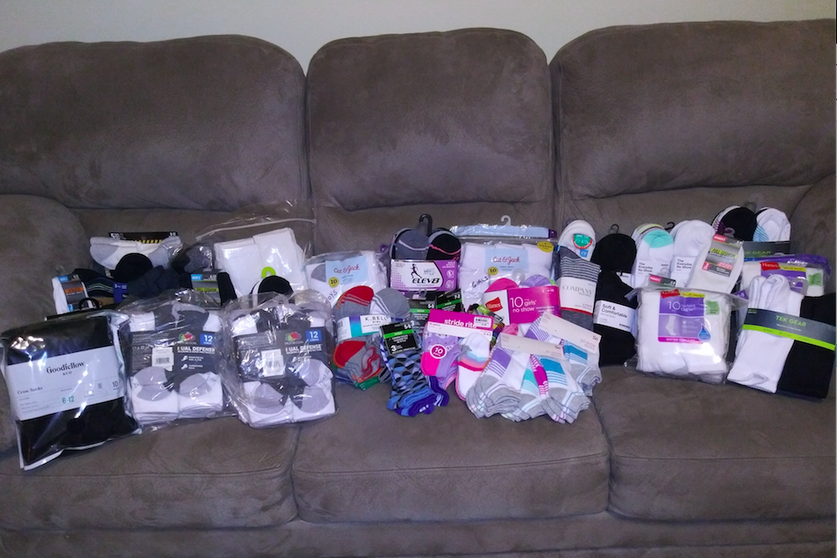

Mid-Florida Milers Newsletter
Membership Report by Dave Piatt, Membership Chairperson
Currently we have 57 memberships and 87 members. This compares to 62 memberships and 88 members on 6/5/20.
Summer has certainly arrived! Remember to be safe and take water with you on your walks and if they are in the afternoon be prepared for any quick showers. With the Mid-Florida Milers, we usually schedule our walks in the morning to take advantage of the slightly cooler temperatures.
Coming to one of our walks is a great way to meet new people. But if you cannot make one of them, you can still take advantage of our Year Round Events.

Membership Renewal by Dave Piatt, Membership Chairperson
Our membership year runs from July 1 to June 30. It is now time to renew your membership for the 2021- 2022 Membership Year.

As we announced at our annual meeting, after many years of maintaining a constant fee we have had to increase our membership fees. If you renew in June- September, a single person membership is $15. The fee for a couple or family is only $25.

Renewing your membership in Mid-Florida Milers is very easy. If none of your contact information has changed then all you need to do is to pay your membership fee at one our walks and tell them nothing has changed. Or if you are not going to be at a walk in the near future, then mail a check payable to Mid-Florida Milers and tell us it is a membership renewal and nothing has changed.

- Mid- Florida Milers
- P. O. Box 4575
- Winter Park, FL 32793

If you need to make some changes to your contact information or you want to join for the first time then you should send in a completed membership form. Go to
- www.midfloridamilers.org

Halfway down the Left Hand Column is the link to click on to download the Membership Application. Just click on it and you will get a pdf version of the application that you can fill out. Just change any new information and turn it in, along with the fee, at a walk or mail to the above address.

We look forward to your renewal and hope to see you on one of our walks soon.
- .

Mid Florida Milers Annual Membership Meeting by Sharon Axelrod, Secretary
The annual Meeting was held on May 14, via Zoom at 4:00 pm. The minutes of the meeting are posted on the MFM web site. Out of 87 members, fourteen members and one guest attended and two membership proxies were received. As Volunteer Coordinator, I spoke to the urgent and critical need for a member to step up as MFM Treasurer, since after ten years Sharon Predham will be stepping down when her term as Treasurer ends as of July 1. Another immediate need is MFM Routes and Trails Coordinator, now that our Trailmaster, Mike Lanpher and his wife have moved to South Carolina. There are three Traditional Events scheduled for the rest of the year that we need volunteers to create. Also, in place of Mike Lanpher the BOD is requesting several members to rotate the responsibilities of transporting, set up, and take down of the materials used at each of our walks. Note: Since the meeting all these requested volunteer positions have been filled. Thank you to our wonderful and dedicated MFM members.

Sharon Predham gave the Financial Report, Dave Piatt presented the Membership Report, and Cathy Metherell read the Route & Trails Report, which departing Trail Master Mike Lanpher had submitted. Dan Barnett discussed the MFM quarterly Newsletter as he has volunteered to take over as Editor.

This year’s election was for Vice President and Treasurer. Dan Barnett agreed to another term as VP and his nomination was unanimously accepted. There was no one at this time volunteering for the Treasurer position

In recognition for all these volunteers do for The Club, President Cathy Metherell presented the following awards.

MFM Certificates of Appreciation to our Year Round Event Route Monitors: Tom Carter, JoAnne Cross, Howard Daughtrey, John Hunter, Michael Kirchner, Joyce Taylor, Gerry Vannienwenhove and Jan Van Vlack.

AVA Meritorious Service Award: Sharon Axelrod.

AVA Commendable Service Awards: Jenny Thomas and Dan Barnett.

MFM Presidential Award: Sharon Predham

Trailmaster Topics by Dan Barnett, Vice President
Mike and Joan Lanpher have moved to South Carolina and have left some big shoes to fill. While our club has had to do some things on the fly, we have maintained our walking program. I want to thank Tom Carter and John Hunter who have volunteered to bring our club equipment and supplies to each of our walks. Also, thank you to Rosemary Barna who has volunteered to be a back-up in case neither Tom nor John can be at any of our walks. Our club has three remaining Traditional Events (TE) for the rest of the year and the remaining walks are Year Round Events (YRE). Thank you to Dave Piatt, Sharon Axelrod and Michael Kirchner for volunteering to be the leads on these three TE’s. The club Board of Directors will be working with the Route and Trail coordinator to develop a 2022 walking schedule that relies on YRE Events and also will have some TE’s. Your help will be appreciated to volunteer to lead the development of these TE’s once they have been identified in our finalized 2022 walk schedule (should be finalized by the end of August or beginning of September. We have exciting walks for the remainder of 2021 and I hope you can come to many of them. Also, please consider attending the Walk Around Florida in November (details contained in the article in this Newsletter.

Walking Information

Q3 Mid-Florida Milers Walks
3 Jul | Lake Buena Vista/Disney Springs | 9:30-10:00 am
17 Jul | Winter Park at AMTRAK Station | 8:30-9:15 am
31 Jul | The Villages Lake Sumter Landing | 9:00-9:45 am
7 Aug | Celebration #1 | 8:30-9:15 am
21 Aug | Orlando South | 8:30-9:15 am
4 Sep | International Drive @ Comfort Suites Hotel, Canada Dr. | 8:30-9:15 am
18 Sep | Oviedo/Tuskawilla – This is a Traditional walk | 8:30-9:15 am
DATE | Q1 Other Florida Upcoming Traditional Events | REGISTER
10 Jul | SS Orange Belt Jamboree, Crews Lake Wilderness Park, 16739 Crews Lake Dr, Spring Hill | Register at ?? am, walk at ??
11 Sep | HW BIKE - Rotary Park, 902 W. Park Ave, Edgewater | Register at 9:00-am ride at 9:30
18 Sep | SS Al Lopez Park, 4810 N Himes Ave, Tampa | Register at ?? am, walk at ??
 | See HW, SS, and FCTF web sites for Wednesday, Saturday and Sunday group walks of YREs
 | The Happy Wanderers. http://www.happywanderersfl.org. Additional walks on Sundays (YREs) & Wednesday evening (ACE walks (non credit fun walks)).
 | Please see the First Coast Trail Forger website for group walks http://www.firstcoasttrailforgerswalkingclub.org.
 | Please see the Suncoast Sandpipers web site http://www.suncoastsandpipers.org. or https://www.facebook.com/suncoastsandpipers.
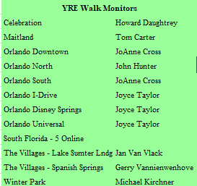
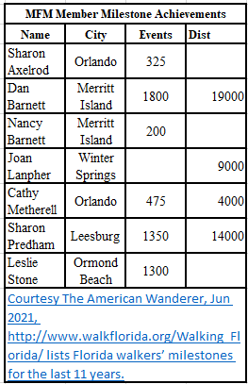

Many AVA Special Programs are supported by MFM events; sign up references at ava.org Current Special Programs for Rockin’, Around the Clock, Mayflower, Carousals Across America, Little Free Library, and Walking w/America’s Vets and others for walks in Florida that provide these walk credits. MFM Special Program walks are shown on our website. Please NOTE, Carousals Across America and Little Free Library both end this year on 31 December. Both allow a further 12 months for the books to be redeemed.

2021 Walk Around Florida by John McClellan, President, Happy Wanderers
Walk Around Florida (WAF 30) in Daytona Beach, Florida is back on in 2021 for November 5-7. Advanced hotel reservations are once again available at the fabulous Plaza Resort and Spa. To reserve a room, call 1-866-500-5630 and say “Walk Around Florida” for a standard king or double queen room at a fantastic group rate. Upgrades to partial view or beachside rooms and extended stays up to three days before and after are also available at a discounted rate, while accommodations last. The Plaza has both indoor and outdoor bar/lounges three on-site food venues and a full-service spa and hair salon. The heated
Pool is surrounded by generous seating and cozy fire pits situated around the resort’s beachside courtyard. In addition, guests have use of paddle-boards, kayaks, boogie boards and bicycles as well as access to multiple hotel activities

Daytona is the World’s Most Famous Beach and the birthplace of NASCAR racing. Fifteen land speed records were set on the flat, hard-packed beaches here before the famed inter-national speedway was opened. At WAF30, you’ll be walking on those same Atlantic Ocean beaches where the cars (still allowed in some stretches) are now limited to 10 mph. Daytona Beach is located on Florida “Fun Coast” in Volusia County, about 51 miles northeast of Orlando by I-4, and 86 miles southeast of Jacksonville by I-95. Daytona International Airport (DAB) provides convenient air travel connections along with Orlando (MCO), Orlando-Sanford (SFB) and Jacksonville.

Sanctioned events at WAF30 include four walks and a swim in the hotel pool, with several more YREs avail-able within a one-hour drive. Our Friday afternoon walk from the Plaza includes a piece of that great beach as well as Jackie Robinson Field. Home of the Daytona Tortugas, the ballpark was the first venue its hall-of-fame namesake played in professionally after being signed the Brooklyn Dodgers. A happy hour Meet-n-Greet back at the hotel on the pool deck will follow the walk.

Our Saturday offerings take walkers to the neighboring coastal towns of New Smyrna Beach and Ormond Beach. An old Florida beach town, the highlight of the New Smyrna walk is the Smyrna Dunes Park, with more than two miles of wide, elevated, handicapped accessible boardwalks and breathtaking views of the Atlantic Ocean, the Indian River and Ponce de Leon Inlet. The highlight of our afternoon walks is Ormond Beach’s Central Park. 150 acres of ponds, canals and walkways. The 10k walkers will also visit Cassen Park, the Grenada Bridge Pier and the Bailey Riverbridge Gardens. Walkers then return to the Plaza for cocktails and our 30th anniversary banquet dinner.

The weekend wraps up on Sunday morning at One Daytona—the new shopping and entertainment venues in the shadow of the Daytona International Speedway. See the famous home of the Daytona 500 and the headquarters of NASCAR. The 10k walkers will also explore the campus of Embry Riddle Aeronautical University, recognized internationally for excellence in aviation and aerospace education. Walkers will enjoy a sendoff lunch at One Daytona before heading out. Our full event brochure with event registration and waive form will be out in time the AVA Convention. Keep watching the AVA and WAF30 Facebook, (facebook.com/WAF30) pages and stay tuned for our next article with more information on the prizes and activities surrounding WAF30. We’re looking forward to seeing you at our 30th Anniversay!

AVA Hosting 18th IVV Olympiad in 2023—Help Us Plan by John McClellan, AVA Convention Committee
America’s Walking Club will host the 18th IVV Olympiad in San Antonio, TX from 19-23 February 2023. This will be the first IVV Olympiad ever in North America, and we need your help! If you are willing to commit to the success of this effort – starting now and continuing through February 2023, please contact us at olympiad2023@ava.org
We have formed an executive planning committee and now it is time to start setting-up the sub-committees we’ll need to pull off this international festival – a full week of events & activities back-to back with the existing IML weekend that began in 2020. Our planning figure for attendance is 2,500 or more from the United States, Canada, and dozens of IVV and IML countries.
Any help is welcomed, but here are some of the attributes / experiences we are looking for:
- People who can serve on a geographically distributed committee – expect to meet mostly by MS Teams or Zoom, at least monthly. You will need computer/internet access, and should be comfortable with MS word, ppt, excel products; and dropbox.com
- People with experience planning large sports events or similar big functions – among these might be – Crazy Horse; the last 2 or 3 AVA Conventions, or multi-event weekends
- People who have specifically attended past international walking events of IVV or IML; or have volksmarched in other countries; or who lived or worked overseas People with language skills, and specifically: German, French (official IVV languages), Italian and Korean (we’ll be going to Seoul in 2022 to market ourselves)
- People with other specific expertise:
- Marketing – to include graphic design, websites, and social media.
- Information Technology – to include website design
- Trailmaster skills
- Recruiting and organizing volunteers Any help is welcomed, but here are some of the attributes / experiences we are looking for:
We are happy to have help from anyone who wants to see our Olympiad succeed, and we’d like to see representation for every region. Right now we’re taking about committee work.As we draw closer to the events themselves, there will be a larger effort to gather the volunteers we’ll need to actually run all of this – probably a couple of hundred!
It’s an exciting time and we are just getting started. Hope you will join us!

AVA Friendly Pets on the Trail from the AVA June Checkpoint

The AVA acknowledges participants on some occasions bring their dog on AVA walks. Although pet friendly participation is encouraged, the AVA requires that pets brought to AVA walks be kept on a leash. This is to ensure the safety of the pet, owner, and other walkers. Clubs and/or sponsors of walks are to enforce this requirement.

Pictures
(Editor comment) All MFM Pictures are found online for the walks completed in 2021 thru 19 Dec. These are from the 2Q events that I took or were provided to me. I urge those that carry cameras (i.e. smartphones) to take and submit pictures of our events.
Mid-Florida Milers 2021 Photos - Walk for Fun (walkflorida.org)
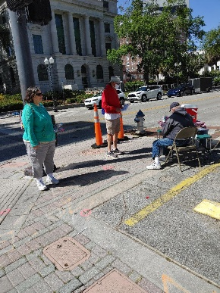
3 April Orlando Downtown
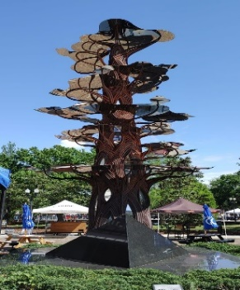
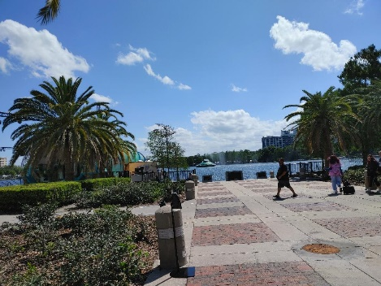

John at Checkpoint

17 April Wetlands at Christmas
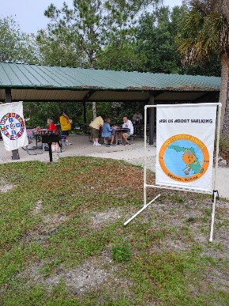
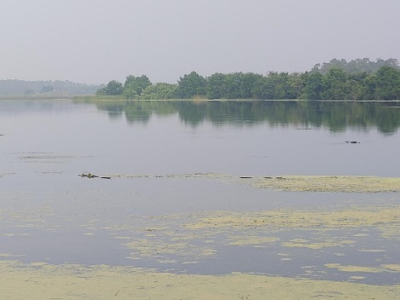
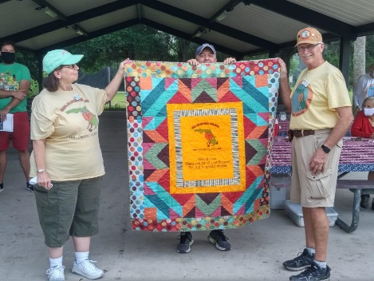

Quilt Presentation to Mike

1 May at Celebration
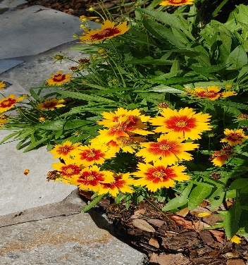
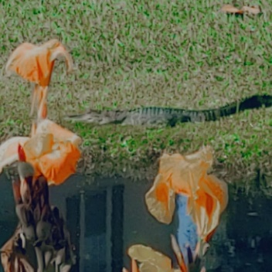
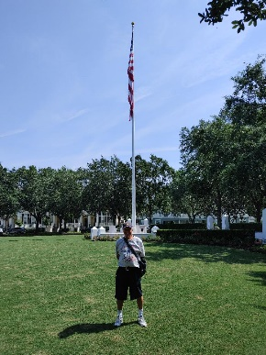
Ron and Rosemary distancing

John near
Veteran Memorial

15 May at The Villages

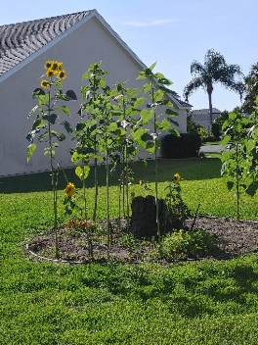
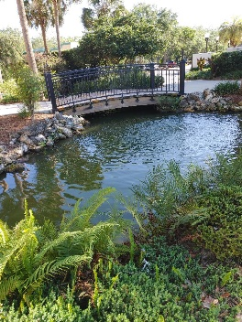
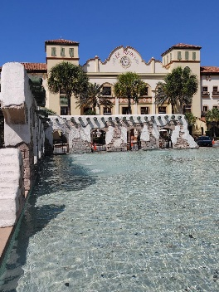
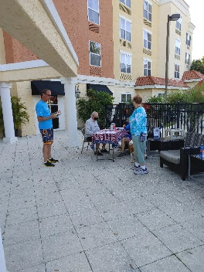

23 May at Maitland
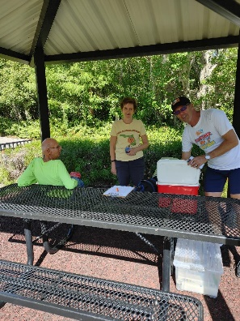
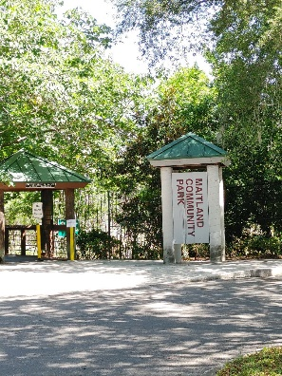
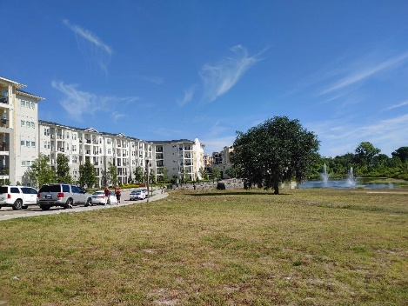
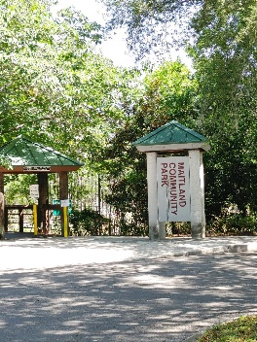

5 Jun at Universal
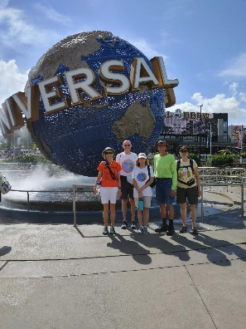

Awards and Recognition
